Big Data Landscape
Applying Machine Learning on Health Professional Shortage Area dataset using BigQuery ML

Abstract
In the attempted coursework, a wide scope of datasets in regards to Health Professionals Shortage Area (HPSA) has been experimented. The Google BigQuery ML has been utilized to yield insights from the dataset. Machine Learning models such as Linear Regression and Logistic Regression have been put into work. Logistic Regression has been used to distinguish different elements of the dataset values. Through the extensive application of machine learning on the dataset, one can propose a promising outcome. So that the medical officials, paramedics, health regulators and medical units can benefit from it. For future analysis, more techniques and algorithms can be experimented on the proposed dataset.

TABLE OF CONTENTS

Abstract 1

Module: 1 3
1.1 Introduction 3
1.2 Problem Statement 3
1.3 Goals of the Experiments 3

Module: 2 4
2.1 Benefits Achieved by the Use of ML in Medicine 4
2.2 Technologies Used for the Machine Learning Application 4
2.3 Critically discussing about the models 5

Module: 3 10
3.1 Task 1 10
3.2 Task 2 13
3.3 Task 3 16

Module: 4 22
4.1 Conclusion 22
4.2 References 23

MODULE 1
  - Introduction
With the headway in the time of innovation and technology, the new rise of advancements in the field of medical, consideration of looking for better and solid solutions have been developed. At least, it impacts directly to the techniques and the choices of the institutes and the organizations. Because of the remarkable development in the field of medicine and the estimation of the occurrence of a disease has revolutionized the world. The scientists have moved to these areas to get their hands on the results which were practically seems unachievable. Various techniques have been used to get onto a result which would prove beneficial to both on the patient and the medical side. Health Professional Shortage Area dataset filled in as the medium to direct the referenced analysis.
  - Problem Statement
HPSA dataset consists of a large amount of information representing about the areas that have been affected by the shortage of the practitioners. Mathematical indicators such as the ratio of practitioner to population depicts a vast gap between health and misery. Many regions of the US were included in the dataset. The dataset has a large amount of elements of different attributes of the problem at hand. To perform machine learning model training, the dataset has to be cleaned, optimized and made compatible with the requirement. Many columns that lacked values or had null values were managed and opted out from being part of the modelling.
  - Goals of the Experiments
The reason for a Health Professional Shortage Area (HPSA) is to distinguish areas of more prominent need so restricted medical care proficient assets can be focused on and coordinated to individuals in those areas. This interaction recognizes regions that need adequate clinicians to meet the essential consideration needs of its occupants. Deficiency assignments depend on the assessment of models set up in government rule. This helps in regulating the areas that are most disclosed to the error prone situations.
Machine Learning will exponentially help out the officials in prioritizing their strategies in order to tackle the problem ahead. That’s why the new innovative and more technical approach proves beneficial.
MODULE 2
2.1 Benefits Achieved by the Use of ML in Medicine
By utilizing Machine Learning techniques and creating models, one organisation can achieve beneficial outcomes to the addition in their return. The estimations and predictions made my ML models can achieve the level of accuracy and precision where humans are not capable of.
“Falsely canny PC frameworks are utilized widely in clinical sciences. Normal applications incorporate diagnosing patients, start to finish drug revelation and advancement, further developing correspondence among doctor and patient, deciphering clinical records, like medicines, and remotely treating patients. While PC frameworks frequently execute undertakings more proficiently than people, all the more as of late, cutting edge PC calculations have accomplished correct-nesses which are at standard with human specialists in the field of clinical sciences. Some guess that it is inevitable before people are totally supplanted in specific jobs inside the clinical sciences. The inspiration of this article is to talk about the manners by which computerized reasoning is changing the scene of clinical science and to isolate publicity from the real world.” [1]
“Propels in computational power matched with monstrous measures of information created in medical care frameworks make numerous clinical issues ready for AI applications.
Legitimate comprehension of the restrictions of calculations by clinicians and appropriate comprehension of clinical information by software engineers is vital to making calculations usable in the center. It very well may be fundamental for organizations to forfeit the privileged insights of their calculation's usefulness so a more far-reaching crowd can vet the techniques and point out wellsprings of blunder that could wind up affecting patient consideration.
We actually appear to be a long way from calculations autonomously working in centers, particularly given the absence of an unmistakable pathway for clinical endorsement. Characterizing the characteristics essential for a calculation to be considered adequately precise for the facility, while tending to the likely wellsprings of blunder in the calculation's independent direction, and being straightforward with regards to where a calculation flourishes and where it fizzles, could take into account public acknowledgment of calculations to supersede specialists in specific undertakings. These difficulties, be that as it may, merit attempting to defeat to all around increment the exactness and proficiency of clinical practices for different infections.”[2].
2.2 Technologies Used for the Machine Learning Application
Google BigQuery with SQL
Google BigQuery is a web-based cloud administration, given by Google Inc. It is exceptionally helpful due its unequaled elements including Server-less-ness, high versatility, and less expensive. It is deliberately intended for multi-cloud level information control for business readiness. With its tremendous accessibility of datasets for various purposes, it likewise gives easy to use climate to specialized and non-specialized clients with equity.
Google BigQuery with Machine Learning (ML) Algorithms
Google BigQuery likewise grows with the Machine Learning highlight alongside numerous other valuable devices. BigQuery ML permits you to create and execute AI models in BigQuery using standard SQL explanations. BigQuery ML democratizes AI by letting SQL experts create models using existing SQL gadgets and capacities. BigQuery ML speeds up by taking out the need to move data that was recently required a tremendous measure of exertion and time.
Simulated intelligence on tremendous datasets requires expansive programming and data on ML frameworks. These requirements keep game plan headway to a little course of action of people inside every association, and they reject data analysts who grasp the data yet have limited AI data and programming fitness. BigQuery ML draws in data specialists to use AI through existing SQL contraptions and capacities. Specialists can use BigQuery ML to manufacture and evaluate ML models in BigQuery. Agents don't need to exchange unassuming amounts of data to accounting pages or various applications or hold on for limited resources from a data science bunch.
2.3 Critically discussing about the models
Man-made intelligence is developing into the general wellbeing area and will significantly affect each part of essential consideration. Artificial intelligence empowered PC applications will assist essential with caring doctors to more readily recognize patients who require additional consideration and give customized conventions to every person. Essential consideration doctors can utilize AI to take their notes, dissect their conversations with patients, and enter required data straightforwardly into EHR frameworks. These applications will gather and examine patient information and present it to essential consideration doctor close by knowledge into patient's clinical necessities.
Training of the Models
With the help of logistic regression model, the yielded better outcomes and gave high number of precision and accuracy. The input features used for Logistic Regression was the HSPA “Primary_HHS_Region_Name” as label, HSPA names of hot areas, and other alike. The various categories in the region were selected as the main training target. It deduced the results that are mentioned below table.

Table 2.3.1: Logistic Regression Model Training Stats
Iteration No. | Data Loss:  Training | Data Loss: Evaluation | Learning Rate | Time Consumed
7 | 0.0044 | 0.0325 | 6.4 | 14.17
6 | 0.0048 | 0.0325 | 12.8 | 12.83
5 | 0.0079 | 0.0343 | 6.4 | 15.23
4 | 0.0166 | 0.0408 | 3.2 | 10.86
3 | 0.0507 | 0.0698 | 1.6 | 13.23
2 | 0.1183 | 0.1297 | 0.8 | 12.01
1 | 0.1766 | 0.1820 | 0.4 | 13.03
0 | 0.2116 | 0.2134 | 0.2 | 8.08

Table 2.3.2: Linear Regression Model Training Stats
Iteration No. | Data Loss:  Training | Data Loss:  Evaluation | Learning Rate | Time Consumed
4 | 0.2193 | 3.7078 | 0.8 | 5.80
3 | 0.2372 | 3.7383 | 0.4 | 4.86
2 | 0.3923 | 3.8718 | 0.4 | 4.68
1 | 3.5689 | 6.6940 | 0.4 | 7.07
0 | 81.1311 | 88.6723 | 0.2 | 3.76

Evaluation of the Models
Evaluation was done with the part of the dataset that was used for model training. Values that were yielded are mentioned below.
Linear Regression
Row | mean_absolute_error | mean_squared_error | mean_squared_log_error | median_absolute_error | r2_score | explained_variance
1 | 0.18864339252529566 | 0.9132493936205135 | 0.037031918105842644 | 0.06414337679044024 | 0.994888264201922 | 0.9948900374061836

Logistic Regression
Row | mean_absolute_error | mean_squared_error | mean_squared_log_error | median_absolute_error | r2_score | explained_variance
1 | 0.9726793927594988 | 0.9645503806329279 | 0.9699889347691146 | 0.9684383615436211 | 0.11550540141127716 | 0.9984233766233767
Below are the graphical representation of the statistics of the resultant evaluation.
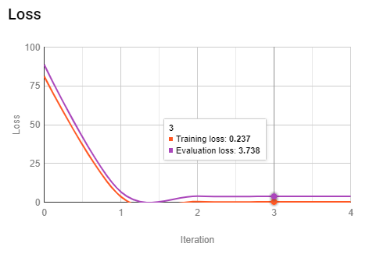
Figure 2.3.1: Loss Vs Iteration, Linear Regression
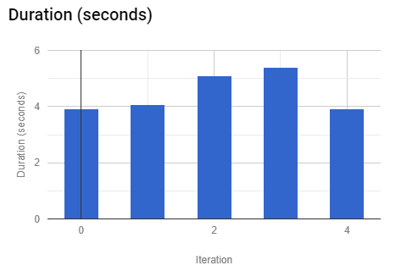

Figure 2.3.2: Duration Vs Iterations, Linear Regression
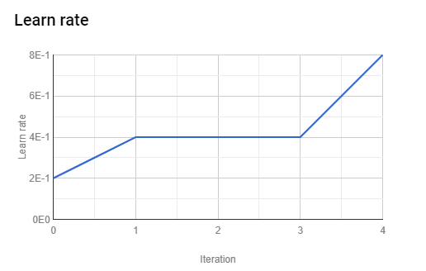
Figure 2.3.3: Learn Rate Vs Iterations, Linear Regression
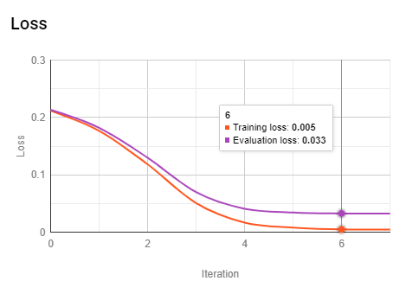
Figure 2.3.4: Loss Vs Iteration, Logistic Regression
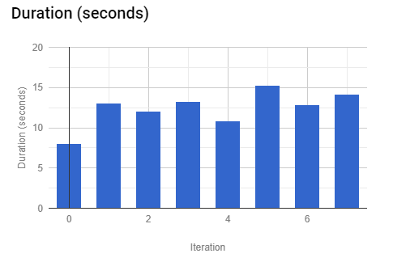
Figure 2.3.5: Duration Vs Iterations, logistic Regression
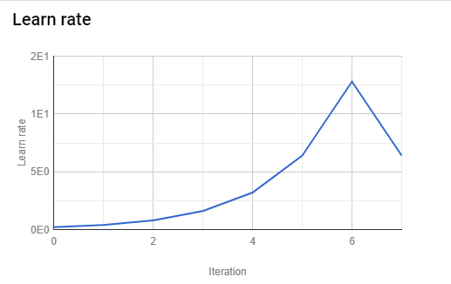
Figure 2.3.6: Learning Rate Vs Iterations, Logistic Regression

Predictions made by the ML models
TABLE 2.3.3: PREDICTIONS USING LOGISTIC REGRESSION MODEL
Row | label | HPSA_Name
1 | Region I | Charter Oak Terrace/Rice Heights
2 | Region I | North Central Hartford
3 | Region I | Low Income - Salem/Peabody
4 | Region I | Low Income - Central Waterbury
5 | Region I | Hillsborough

Table 2.3.4: Predictions using Linear Regression Model
Row | label | HPSA_Name
1 | 0.0 | R.E. Thomason General Hospital
2 | 0.0 | Human Services Center
3 | 0.0 | Thundermist Health Center of South County
4 | 0.0 | Central Health Center Providence
5 | 0.0 | Allen Berry Health Center

MODULE 3
It comprises of the steps of creating, training, evaluating and predicting the machine learning models.
3.1 Task 1
Creating Models
Linear Regression
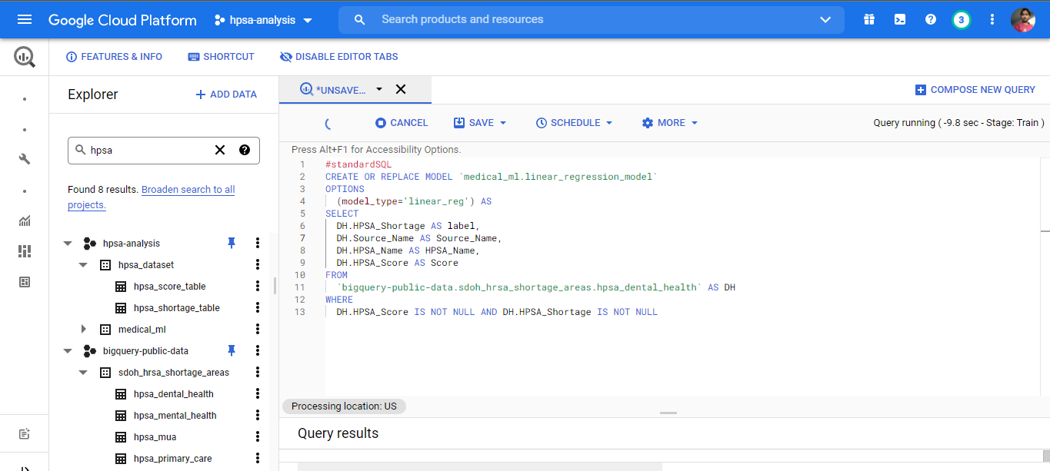
Figure 3.1.1: Creating Model for Linear Regression
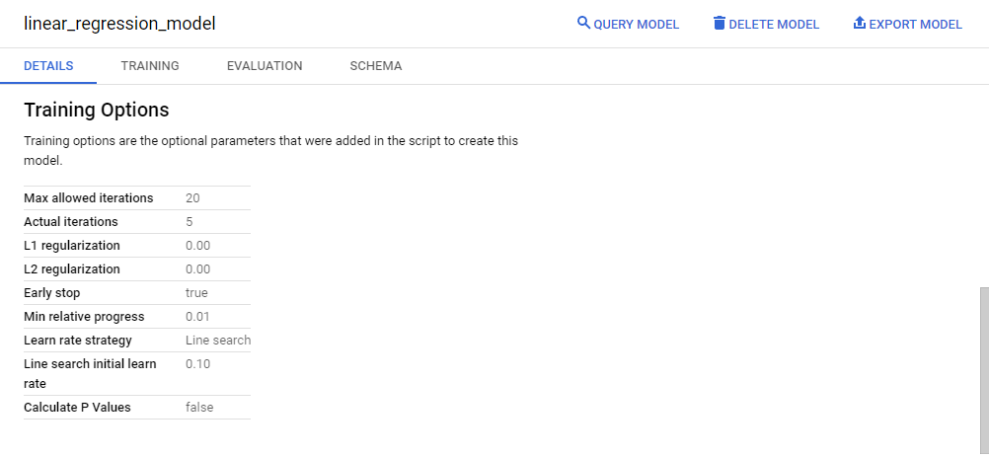
Figure 3.1.2: Result

Executed query.
BigQuery ML Query:
#standardSQL
CREATE OR REPLACE MODEL `medical_ml.linear_regression_model`
OPTIONS
(model_type='linear_reg') AS
SELECT
DH.HPSA_Shortage AS label,
DH.Source_Name AS Source_Name,
DH.HPSA_Name AS HPSA_Name,
DH.HPSA_Score AS Score
FROM
`bigquery-public-data.sdoh_hrsa_shortage_areas.hpsa_dental_health` AS DH
WHERE
DH.HPSA_Score IS NOT NULL AND DH.HPSA_Shortage IS NOT NULL
Logistic Regression

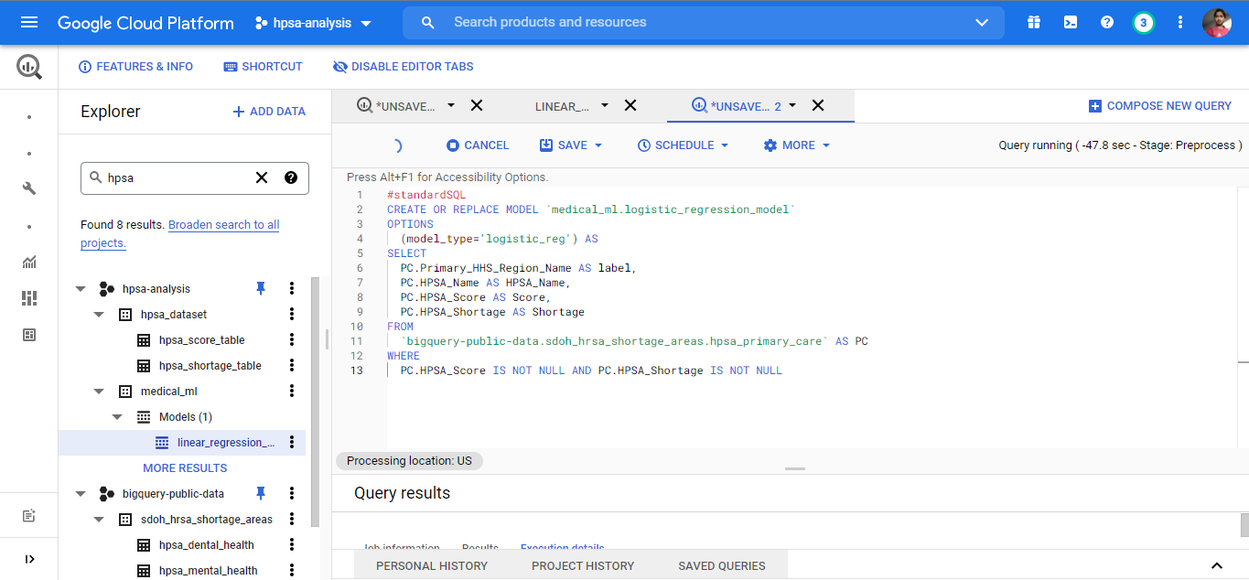
Figure 3.1.3: Creating Model of Logistic Regression
Result of the Query.
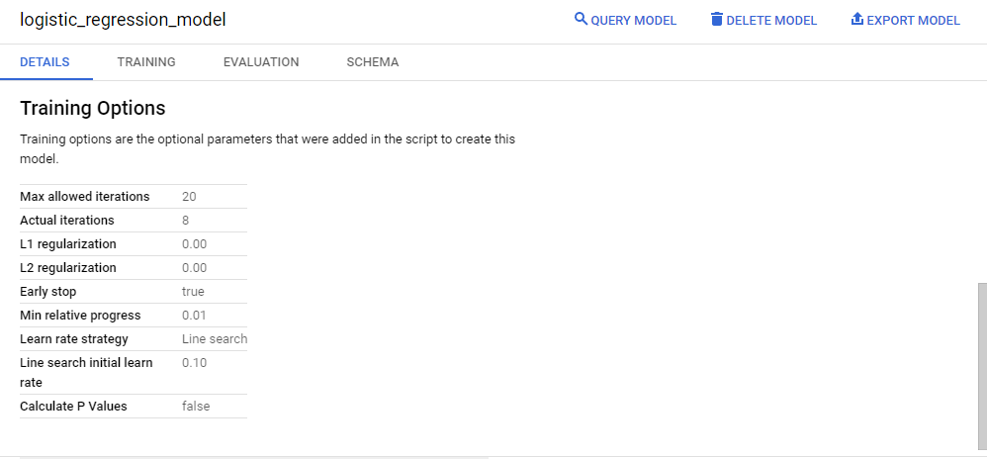
Figure 3.1.4: Result

BigQuery ML Query:
#standardSQL
CREATE OR REPLACE MODEL `medical_ml.logistic_regression_model`
OPTIONS
(model_type='logistic_reg') AS
SELECT
PC.Primary_HHS_Region_Name AS label,
PC.HPSA_Name AS HPSA_Name,
PC.HPSA_Score AS Score,
PC.HPSA_Shortage AS Shortage
FROM
`bigquery-public-data.sdoh_hrsa_shortage_areas.hpsa_primary_care` AS PC
WHERE
PC.HPSA_Score IS NOT NULL AND PC.HPSA_Shortage IS NOT NULL

3.2 Task 2
Evaluating Models
Linear Regression Model
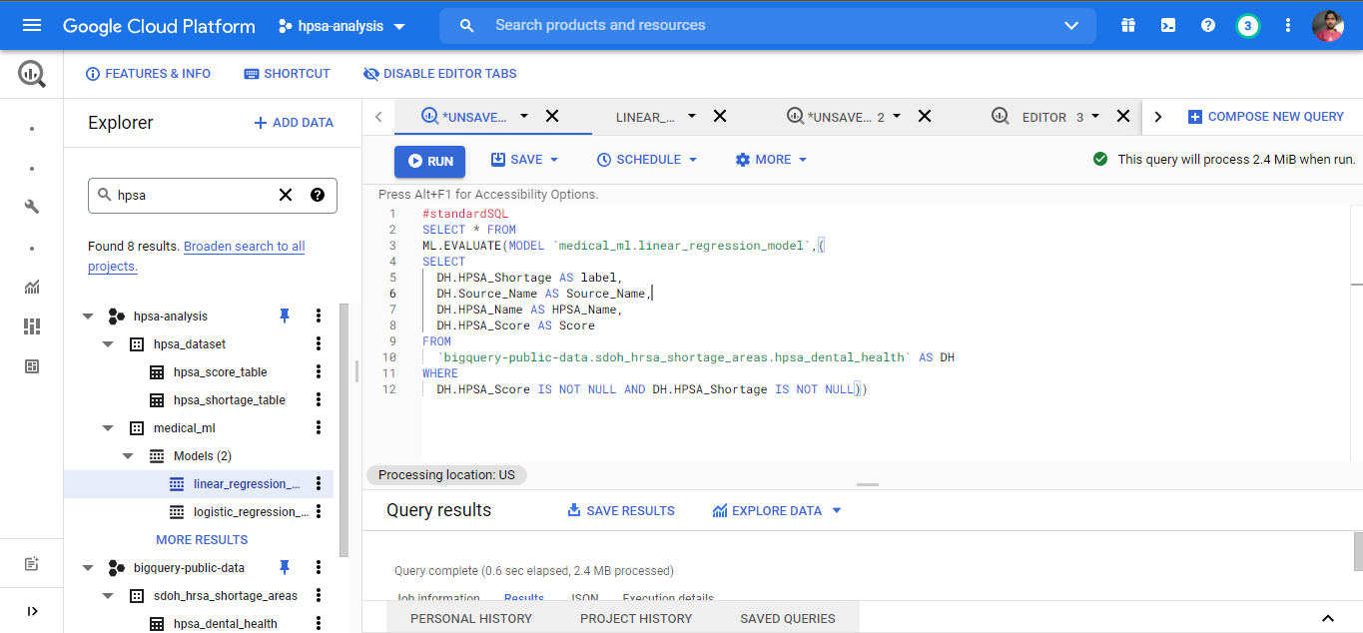
Figure 3.2.1: Evaluating ML Model of Linear Regression
Result of the query.
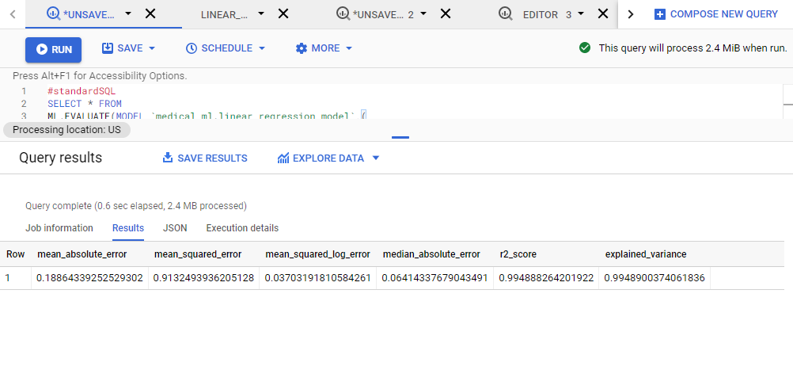
Figure 3.2.2: Result

BigQuery ML Query:
#standardSQL
SELECT * FROM
ML.EVALUATE(MODEL `medical-337614.medical_ml.linear_regression_model`,(
SELECT
DH.HPSA_Shortage AS label,
DH.Source_Name AS Source_Name,
DH.HPSA_Name AS HPSA_Name,
DH.HPSA_Score AS Score
FROM
`bigquery-public-data.sdoh_hrsa_shortage_areas.hpsa_dental_health` AS DH
WHERE
DH.HPSA_Score IS NOT NULL AND DH.HPSA_Shortage IS NOT NULL))
The image below displays the details regarding the model after training.

Logistic Regression Model
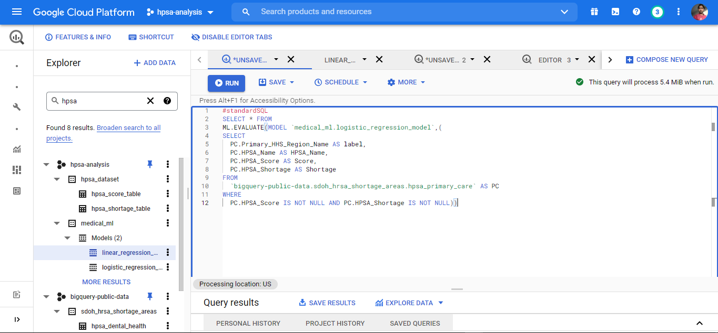
Figure 3.2.3: Evaluating Model of Logistic Regression

Result of the query.
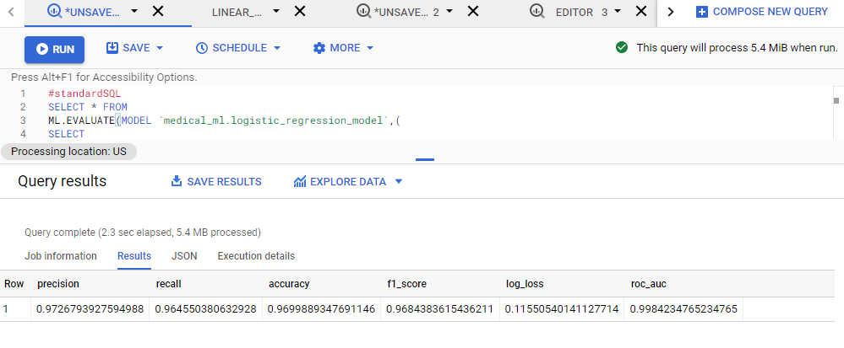
Figure 3.2.4: Result

BigQuery ML Query:
#standardSQL
SELECT * FROM
ML.EVALUATE(MODEL `medical_ml.logistic_regression_model`,(
SELECT
PC.Primary_HHS_Region_Name AS label,
PC.HPSA_Name AS HPSA_Name,
PC.HPSA_Score AS Score,
PC.HPSA_Shortage AS Shortage
FROM
`bigquery-public-data.sdoh_hrsa_shortage_areas.hpsa_primary_care` AS PC
WHERE
PC.HPSA_Score IS NOT NULL AND PC.HPSA_Shortage IS NOT NULL))

3.3 Task 3
Predicting Models
Linear Regression Model
Query: 01
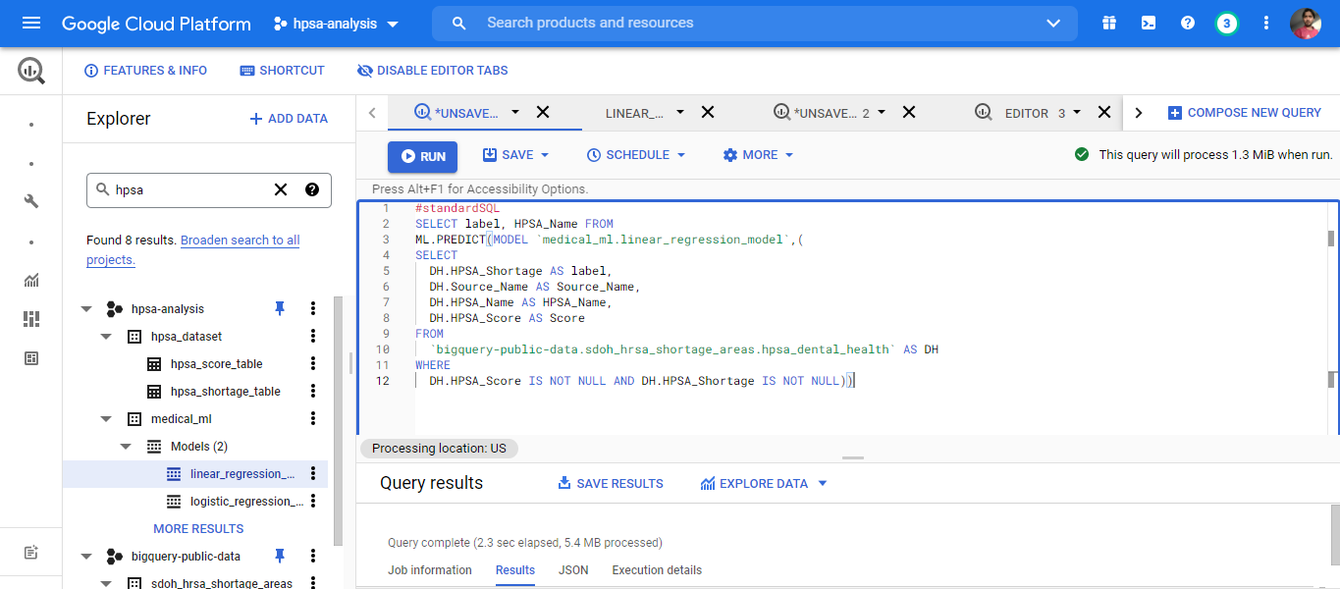
Figure 3.3.1: Predicting Model for query 01 of Linear Regression
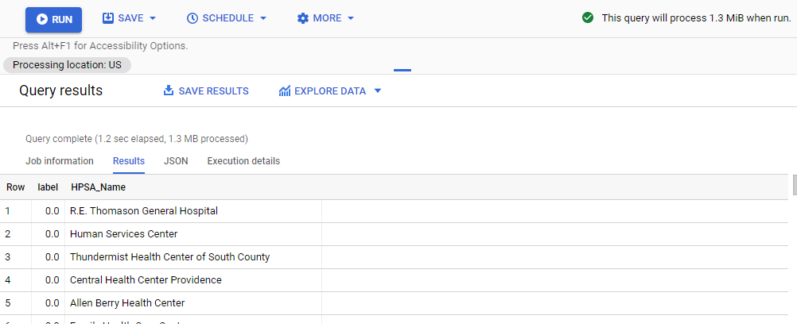
Figure 3.3.2: Predicting Model for query 01 result

BigQuery ML Query:
#standardSQL
SELECT label, HPSA_Name FROM
ML.PREDICT(MODEL `medical_ml.linear_regression_model`,(
SELECT
DH.HPSA_Shortage AS label,
DH.Source_Name AS Source_Name,
DH.HPSA_Name AS HPSA_Name,
DH.HPSA_Score AS Score
FROM
`bigquery-public-data.sdoh_hrsa_shortage_areas.hpsa_dental_health` AS DH
WHERE
DH.HPSA_Score IS NOT NULL AND DH.HPSA_Shortage IS NOT NULL))

Query: 02

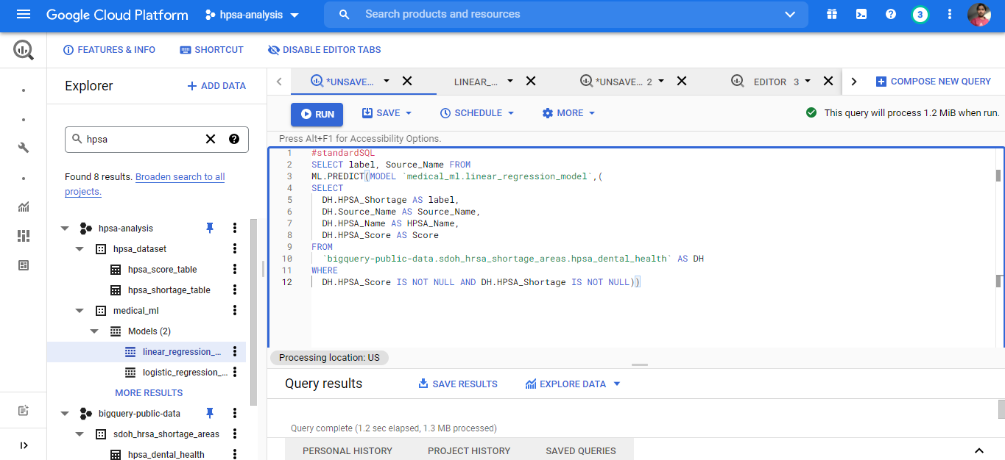
Figure 3.3.3: Predicting Model for query 02 of Linear Regression
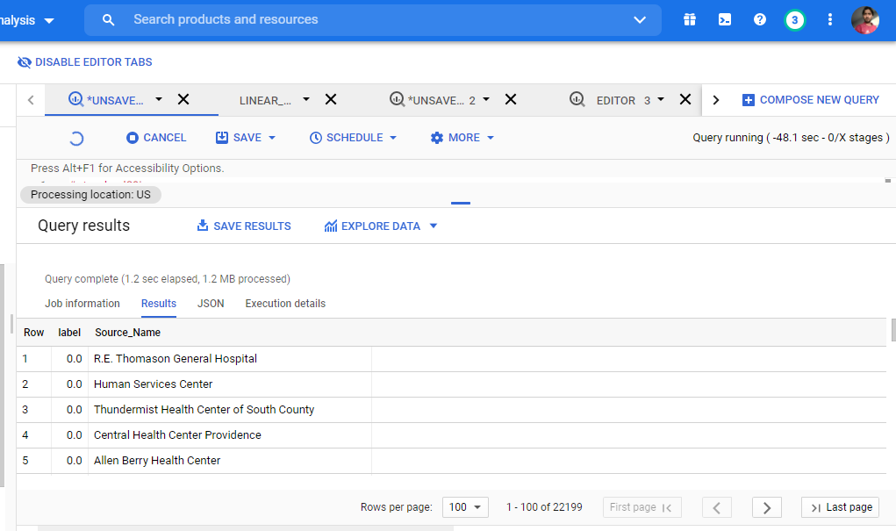
Figure 3.3.4: Predicting Model for query 02 result
BigQuery ML Query:
#standardSQL
SELECT label, Source_Name FROM
ML.PREDICT(MODEL `medical_ml.linear_regression_model`,(
SELECT
DH.HPSA_Shortage AS label,
DH.Source_Name AS Source_Name,
DH.HPSA_Name AS HPSA_Name,
DH.HPSA_Score AS Score
FROM
`bigquery-public-data.sdoh_hrsa_shortage_areas.hpsa_dental_health` AS DH
WHERE
DH.HPSA_Score IS NOT NULL AND DH.HPSA_Shortage IS NOT NULL))

Logistic Regression Model
Query: 01

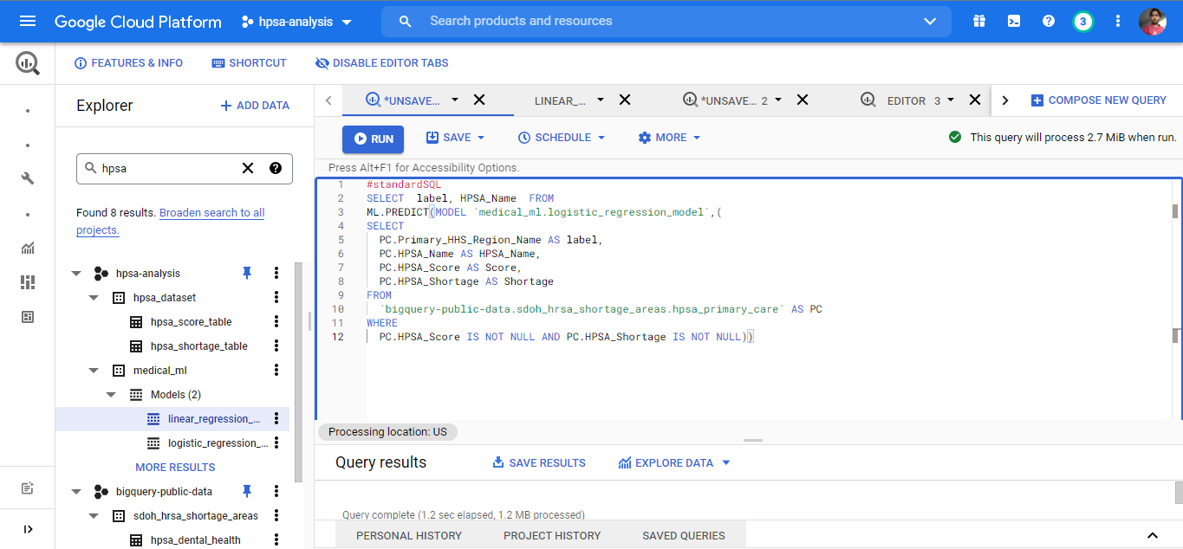
Figure 3.3.5: Predicting Model for query 01 of Logistic Regression

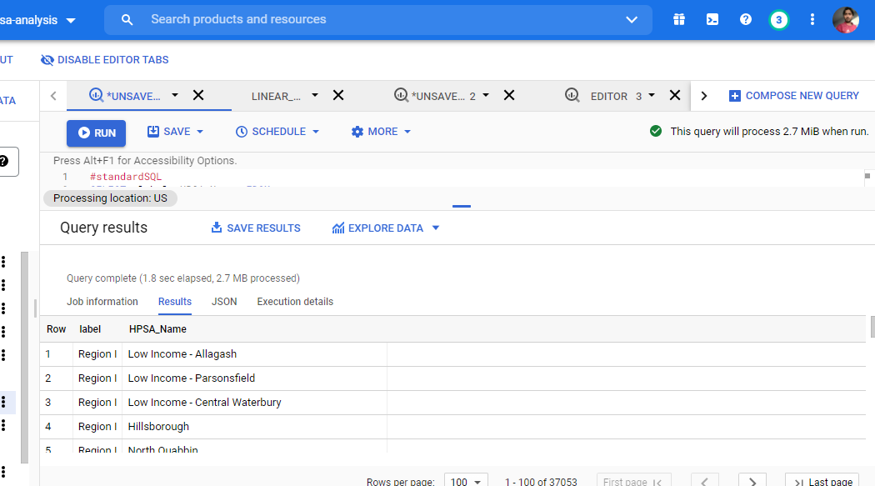
Figure 3.3.6: Predicting Model for query 01 result
BigQuery ML Query:
#standardSQL
SELECT label, HPSA_Name FROM
ML.PREDICT(MODEL `medical_ml.logistic_regression_model`,(
SELECT
PC.Primary_HHS_Region_Name AS label,
PC.HPSA_Name AS HPSA_Name,
PC.HPSA_Score AS Score,
PC.HPSA_Shortage AS Shortage
FROM
`bigquery-public-data.sdoh_hrsa_shortage_areas.hpsa_primary_care` AS PC
WHERE
PC.HPSA_Score IS NOT NULL AND PC.HPSA_Shortage IS NOT NULL))

Query: 02
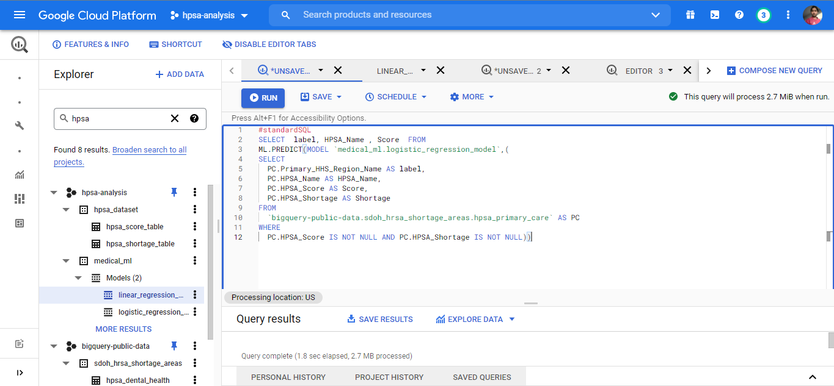
Figure 3.3.7: Predicting Model for query 02 of Logistic Regression

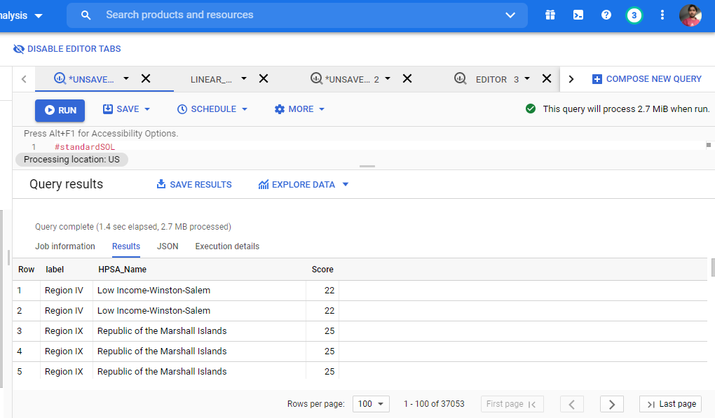
Figure 3.3.8: Predicting Model for query 02 result

BigQuery ML Query:
#standardSQL
SELECT label, HPSA_Name , Score FROM
ML.PREDICT(MODEL `medical_ml.logistic_regression_model`,(
SELECT
PC.Primary_HHS_Region_Name AS label,
PC.HPSA_Name AS HPSA_Name,
PC.HPSA_Score AS Score,
PC.HPSA_Shortage AS Shortage
FROM
`bigquery-public-data.sdoh_hrsa_shortage_areas.hpsa_primary_care` AS PC
WHERE
PC.HPSA_Score IS NOT NULL AND PC.HPSA_Shortage IS NOT NULL))
MODULE 4
4.1 Conclusion
Machine Learning has revolutionized the way of seeing the things now a days. The exploitation of AI in every field of science has emerged as an inevitable phenomena. Numerous organizations are seems to be attracted towards the marvelous achievements of AI. A hands on example of it is the medical exposure of machine learning techniques. It has put an everlasting impact on the working criteria of the many traditional ways.
Utilizing the machine learning modeling technique, it is derived that the areas which are most probably near to be get affected by the health professional shortage are due to the lack of appropriate educational, transportation and medical emergencies. This has been proven by the very experiments being conducted on the HPSA dataset of various regions and the areas.

4.2 References
[1] Basu, K., Sinha, R., Ong, A., & Basu, T. (2020). Artificial Intelligence: How is It Changing Medical Sciences and Its Future?. Indian journal of dermatology, 65(5), 365–370. https://doi.org/10.4103/ijd.IJD_421_20
[2] Daniel Greenfield is a first-year graduate student in the Biophysics PhD Program at Harvard.
https://sitn.hms.harvard.edu/flash/2019/artificial-intelligence-in-medicine-applications-implications-and-limitations/

